Academic title Name Surname¹⁾

University, Faculty

Departament

¹⁾e-mail

TITLE

Keywords: keywords

Abstract:

(max 200 words)

Below is an example of text formatting in a monograph. We remind you that the chapter in the monograph should contain 20 thousand characters.
Introduction

Environmental engineering is an area constantly being developed. Research
in this area focuses on improving already known methods, combining them, getting the best results at the lowest possible cost. Ultrasounds have been used for many years in medical diagnostics, air purification and defectoscopy. Currently, they attract researchers attention also in the field of applications in environmental engineering, for example in water treatment, in wastewater treatment processes and in the treatment of sludge. Figure 1 shows the applications of ultrasound in environmental engineering.

Fig. 1. Application of ultrasounds in environmental engineering
Source: [20]

Basics of the sonication process

Figure 2 shows the frequency range of elastic waves that occur in nature
or are technically possible. This is a very wide range compared to an area that includes audible sounds ranging from 16 Hz to 16 kHz. The frequency range below 16 Hz includes infrasounds. The upper limit of hearing was accepted at 16 kHz
and sometimes 20 kHz. This limit marks the beginning of the ultrasonic region. Elastic waves above this limit can be registered with different devices, but they
are not recorded by the human ear. These waves were called ultrasounds. The term includes elastic waves up to 10⁹ Hz. The upper limit of the ultrasonic region was determined by the ability to produce such sounds. The elastic waves of higher frequencies, occurring naturally as heat waves associated with vibrations of the center molecules and atoms in the crystal lattice, were called hypersounds. The range
of hypersounds goes up to the frequency limit of 10¹³ Hz [17].
Research and development works carried out in Polish institutes [1, 4, 5, 20] clearly demonstrate the applicability of ultrasonic technology in the technological process of wastewater treatment and utilization of sludge, as shown schematically in Figure 4.
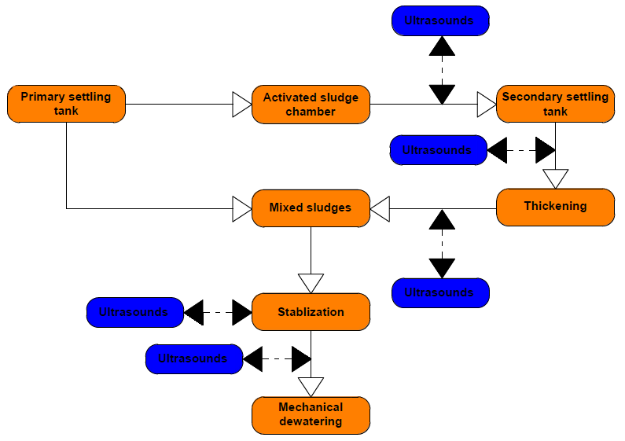
Fig. 4. Variants of the application of the ultrasonic disintegration process of wastewater and sludge
Source: [20]

Based on the review of the above-mentioned works, it was found that the use of the sludge disintegration process is possible at many points of the wastewater treatment line as well as the treatment of sludge. Among the anticipated benefits that disintegration should bring at various points in the technological scheme, there is an improvement in the denitrification process, a decrease in excess sludge growth in sewage treatment plants with oxygen stabilization, an increase in biogas production in anaerobic digestion treatment plants, including methane participation.
It is planned to increase the degree of fermentation or shorten fermentation
and improve the digestibility of dewatered sludge. Additionally, it is possible
to mention the liquidation of foam in fermentation chambers and the biological part of the sewage treatment plant as well as the reduction of the activated sludge index. Studies were carried out on the basis of which changes in the structure of sludge were demonstrated using ultrasonic disintegration. Depending on the energy input, changes in the properties of the tested sediments were obtained. At the same time, the potential for using ultrasounds has been demonstrated, as well as ensuring
an increase in efficiency, and thus a reduction in costs, especially in relation
to the technological flow of sewage treatment plant settlements. These include:
- optimizing the use of flocculants,
- optimization of flocculation and drainage processes,
- creating compact, shear-resistant flocks,
- better release of capillary water, biological water,
- structural changes of sludge through the use of ultrasounds (destruction of binding fibers, degassing).

Summary

The presented examples show that the use of the ultrasonic field has found
its place in environmental engineering, in water treatment, wastewater treatment and sludge management. Researchers are focused on unconventional methods
and on the combination of conventional and unconventional methods. Ultrasounds have found their application as an independent method of changing the parameters of water, sewage or sediments, but also as a supporting factor, accelerating the action or increasing the effect of the process.
The undoubted advantage of using ultrasonic waves in environmental engineering is their non-chemical nature (not introducing new compounds into the environment), while maintaining the appropriate output parameters of water, sewage
or sludge.
The use of the sonification phenomenon seems to be an interesting alternative compared to physical-chemical processes (including coagulation or chemical precipitation). The use of ultrasonic field in the sewage technology does not require
the addition of oxidants or catalysts and does not generate additional waste streams. Ultrasounds can be treated as "green" techniques due to their high efficiency, low instrumental requirements as well as significantly reduce the duration of unit processes in comparison with other known techniques.
Due to the anticipated benefits, it should be assumed that the use of ultrasound on a technical scale will occur more often, especially in combination with other methods, such as biological decomposition.

Literature

- Bień J.B., Wolny L., Jabłońska A., Sewage sludges preparation for dewatering with ultrasonic field application, Engineering and Protection of Environment 2001, 4(1), p. 9–16.
- Grosser A., Kamizela T., Neczaj E., Treatment of Wastewater from the Fibreboard Production Enhanced with Ultrasound Sonifocation in the SBR Reactor, Engineering and Protection of Environment 2009, 12(4), p. 295–305.
- Tiehm A., Nickel K., Neis U., The use of ultrasound to accelerate the anaerobic digestion of sewage sludge, Water Science and Technology 1997, 36(11), p. 121–128.

